**Mapping** (Clear relationship between control and effect)

BAD

A bad example of mapping is this 5-switch panel in the entrance of my friend’s house. He can’t ever remember which switch if for which light because they’re not even in order or up and down or in the figure that simulate the map of the lights. One is for the outside lights, one the closet light, one the foyer, one the living room and one for the fan. Is bad because it doesn’t have a good relationship between the control and what effect has on each bulb.

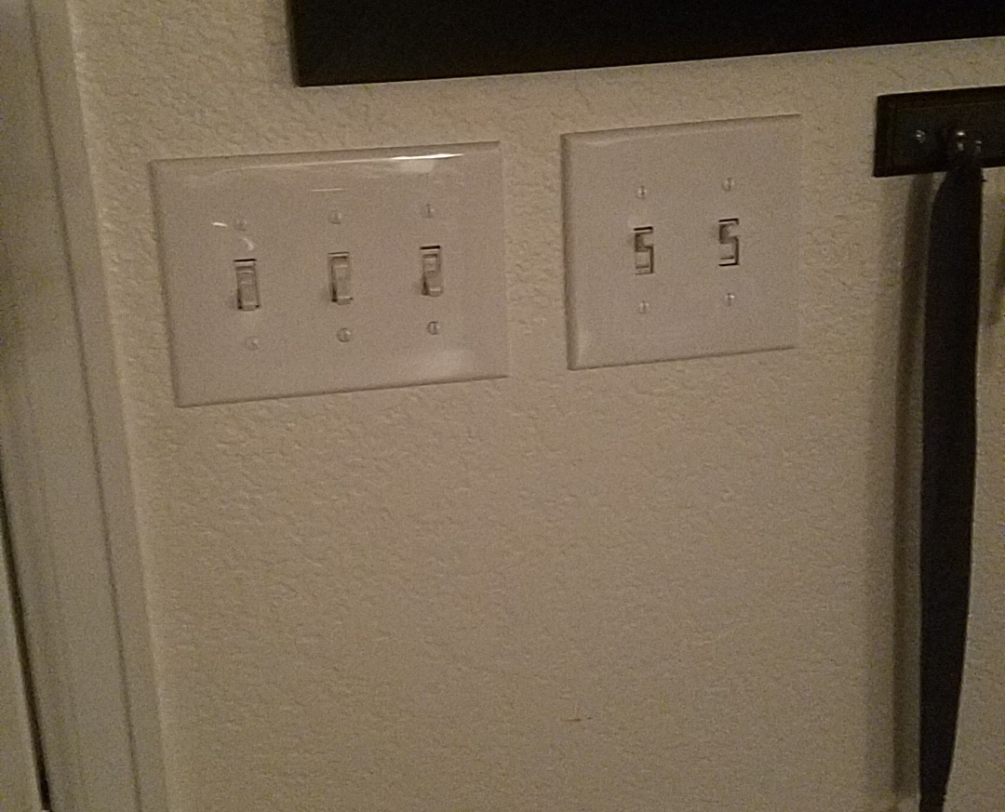

GOOD

My stove has a good mapping and even words to avoid any confusion. It is a good example because you can see in red which one is the one that you will turn on and the mapping is exactly as the mapping of the stove. It also has the LO, MED and HIGH that helps know where to turn the little knob to not burn the food.

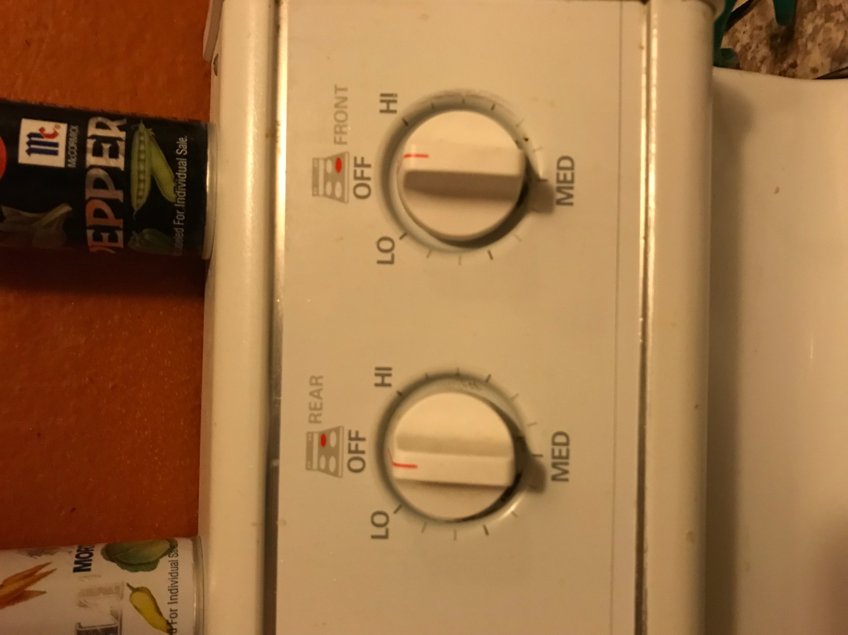

**Affordance** (Allowing people to know how to use it)

BAD

A bad example is the A/C and heather I have in my room because just by seeing it, you have no idea that it has the controls under the little lid. I had to call the manager to know how to turn it on. It is bad because it is impossible to know they’re under that lid that doesn’t even look like a lid. It is even worse because the two ends of the AC/ and heater system, are exactly the same.

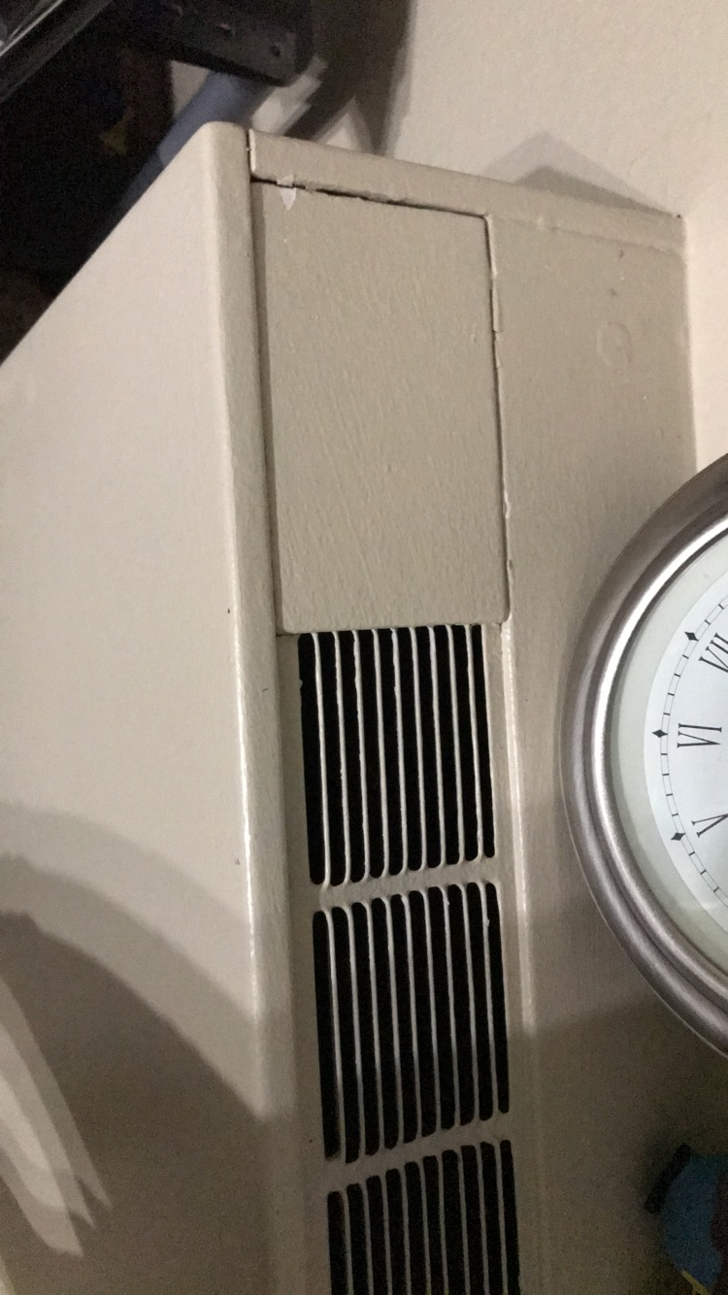 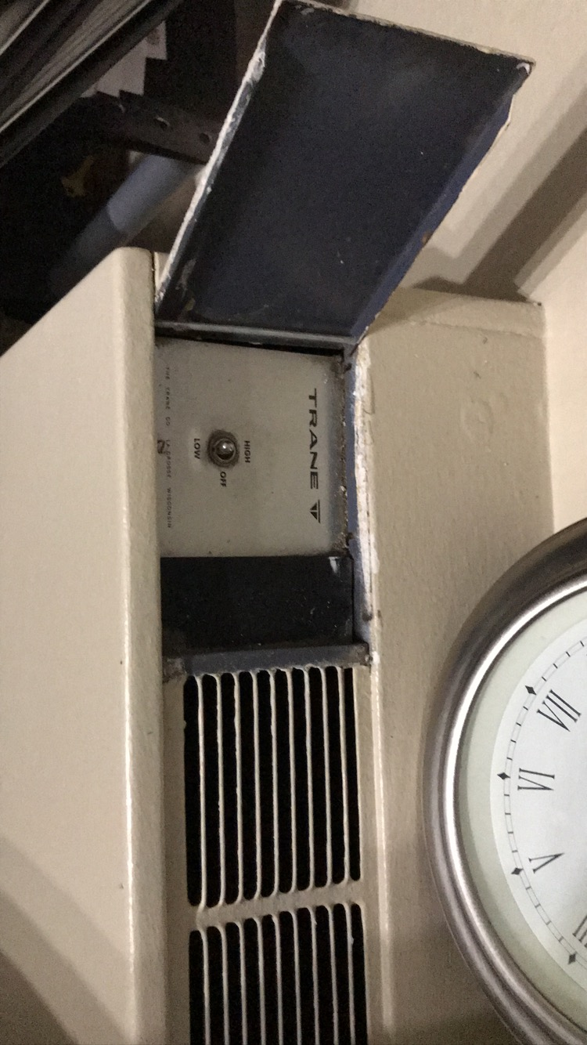

GOOD

The upper lock on my door lets you know in what positions it means your door is locked. Is a good example because you are not confused about when your door is locked or not and is not many words or nothing extra that would change the design.

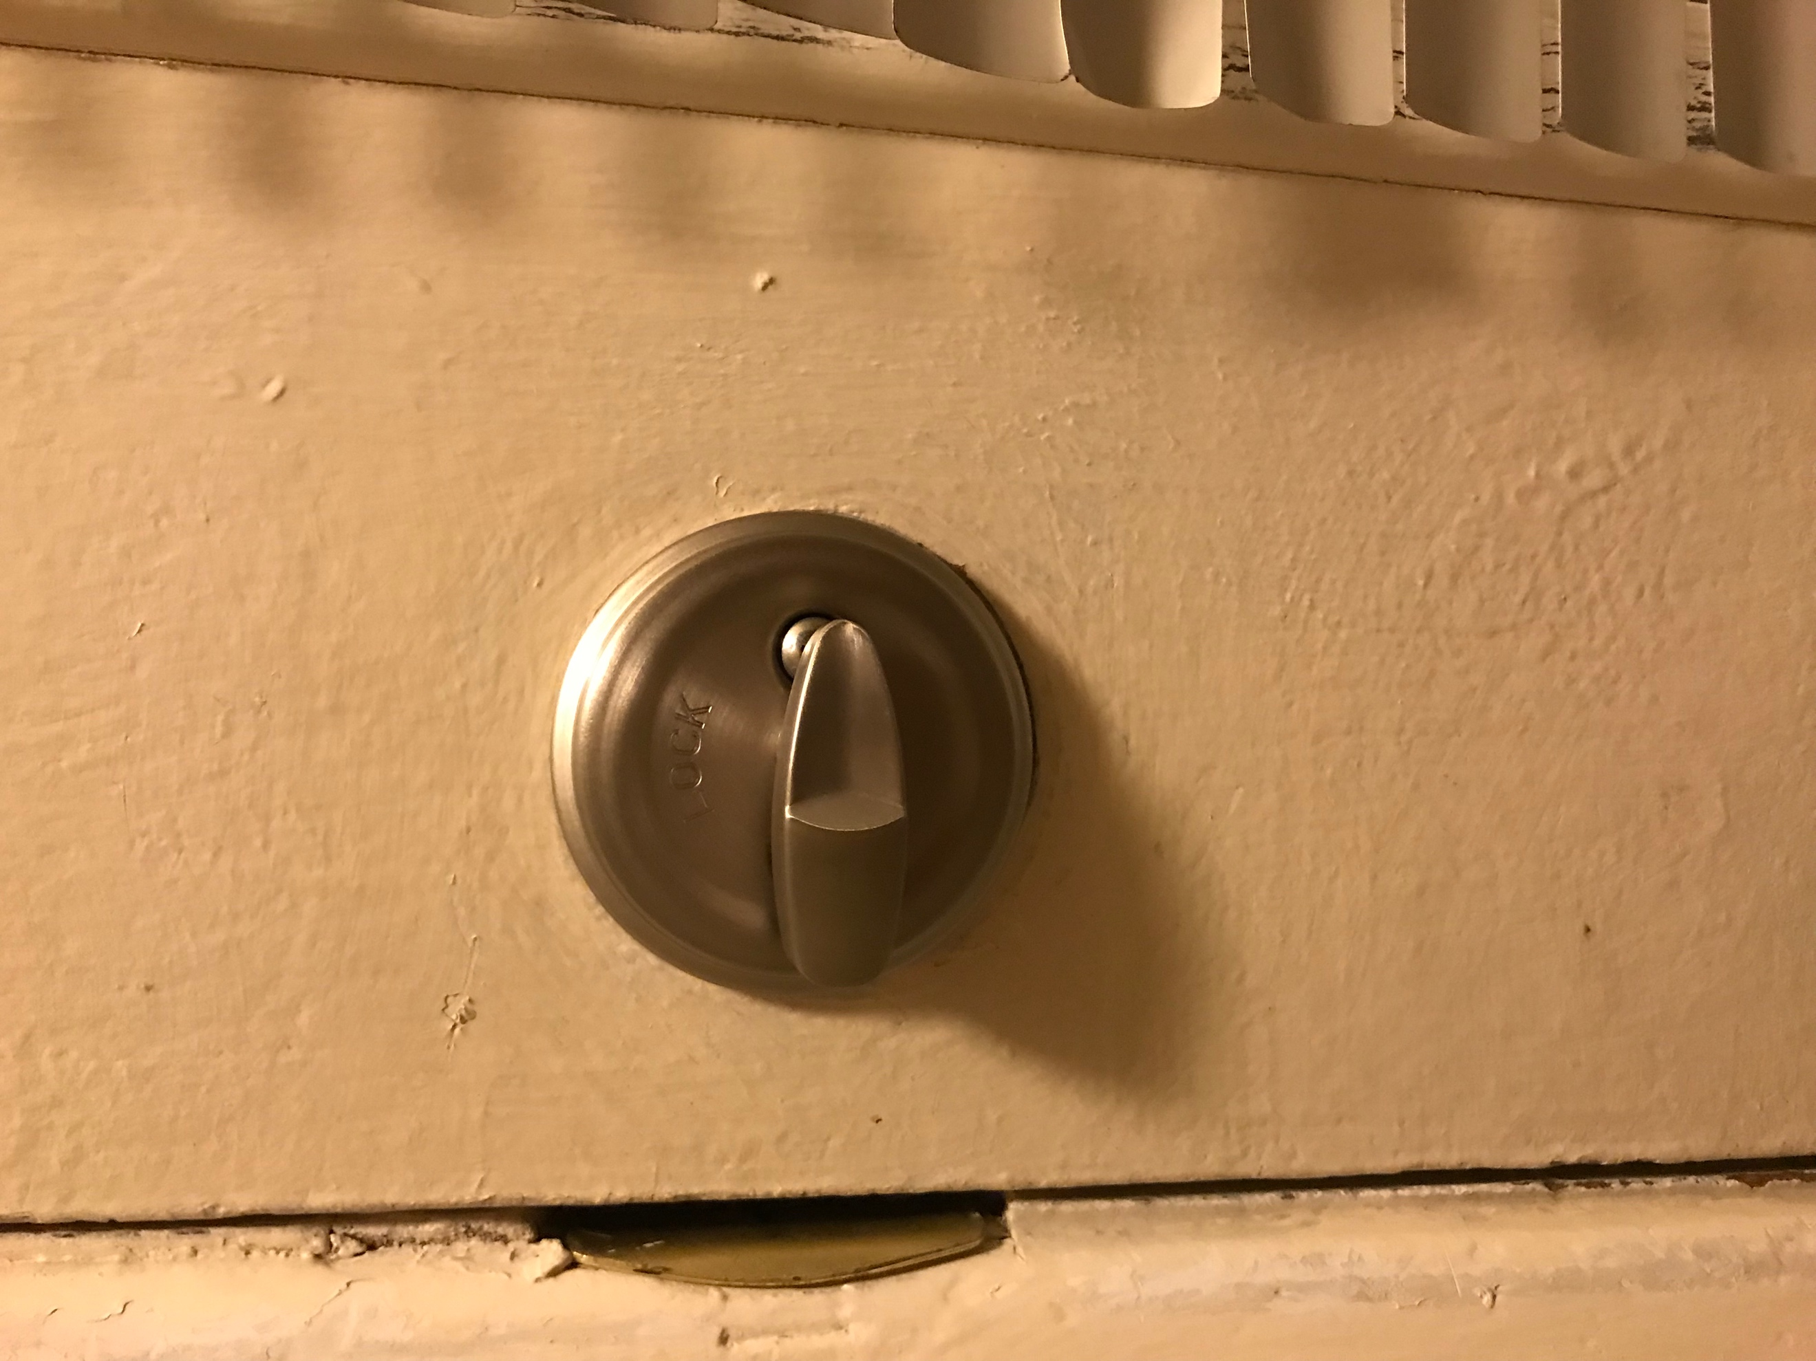

**Constraint** (Limiting the chance of error or bad interaction)

BAD

This control remote has an On/Off button in the back of it. This can cause the user to push it without intention and turning off or on the TV. It is bad because this double button, one in the back, increases the chance of error instead of reducing it.

 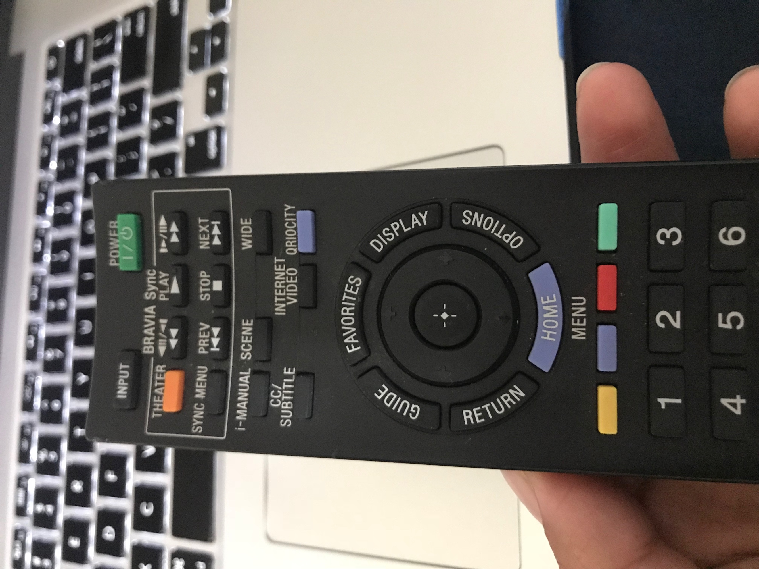

GOOD

The cap/lid of this bottle of makeup is a good example of constraint because it gives the user only two options, to be able to push it down to get the makeup, or to lock it by not being able to push it down so nothing comes out of it. This helps reduce the error of closing it wrong or some other error that could end on your makeup getting out of the bottle.

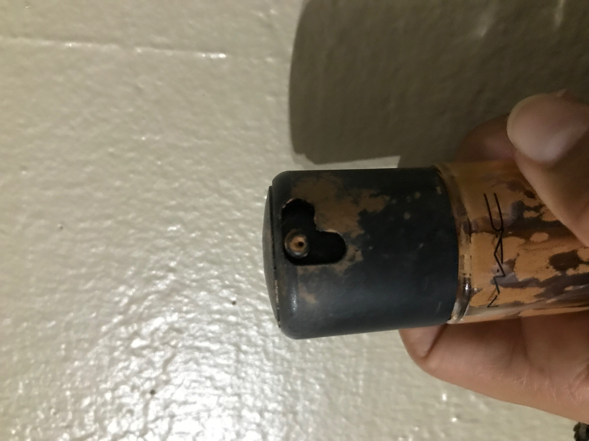 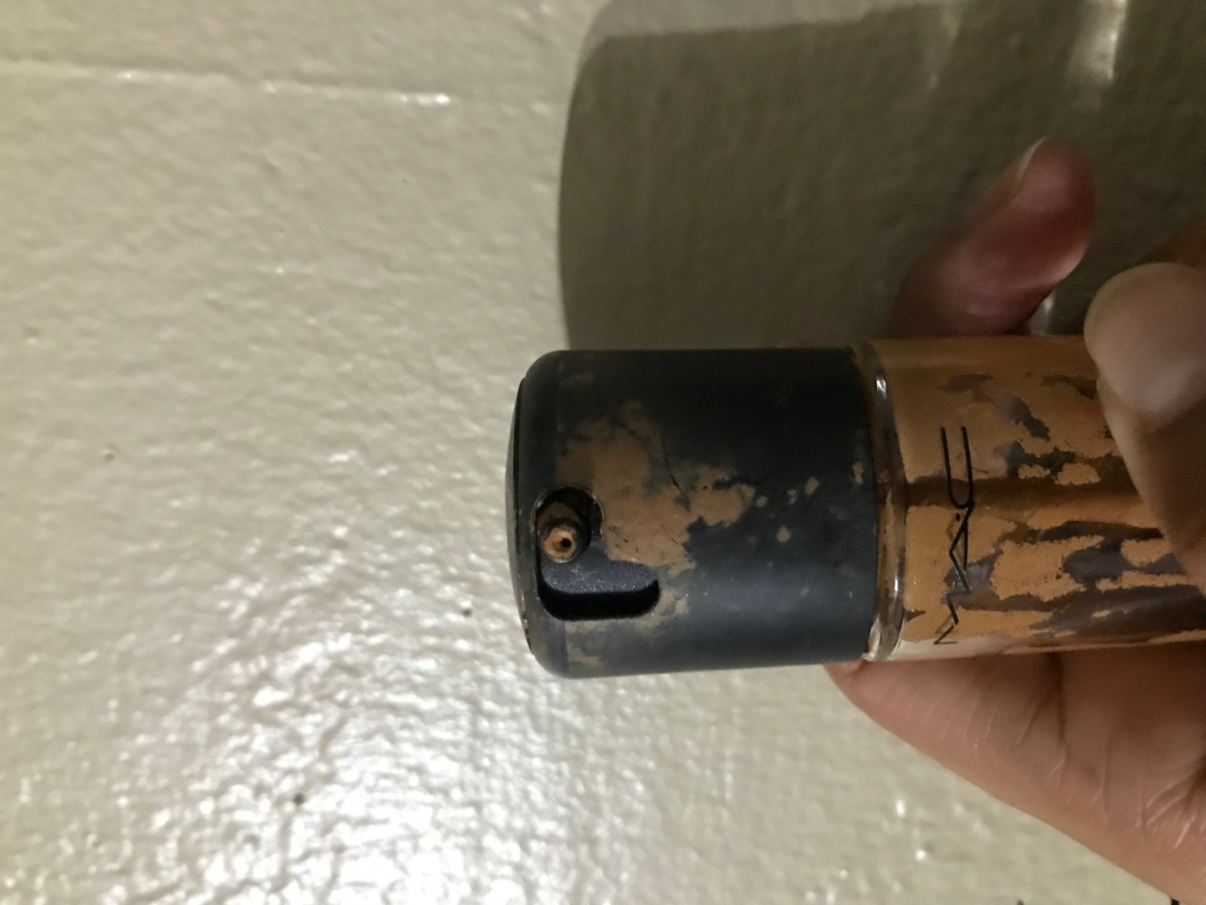

**Feedback** (Making clear an action was taken or accomplished)

BAD

This door handle does not have any feedback or indicator that the door is locked. It is a poor use of the feedback because you have to double check, even triple check, that the door is locked since there is no feedback. Is even hard to know how to lock it. I am sure my roommate hasn’t figured it out because after 2 months of moving here, no one knew how to lock the bathroom door. There no feedback at all but trying to open it and make sure it doesn’t.

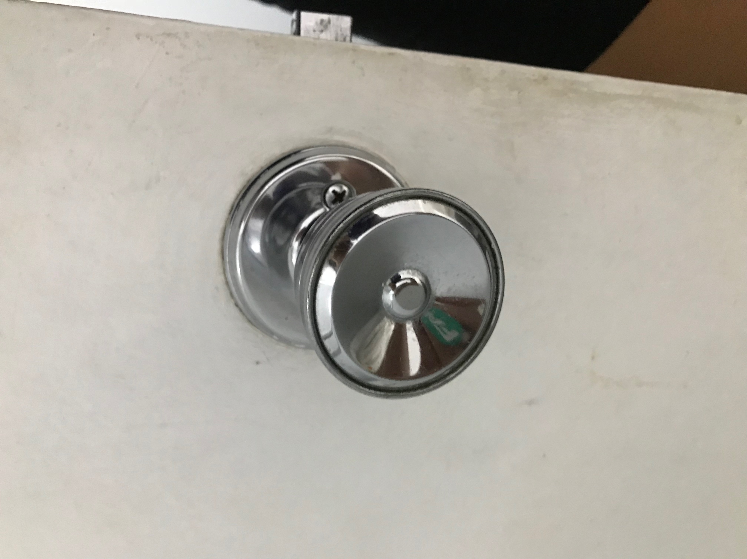 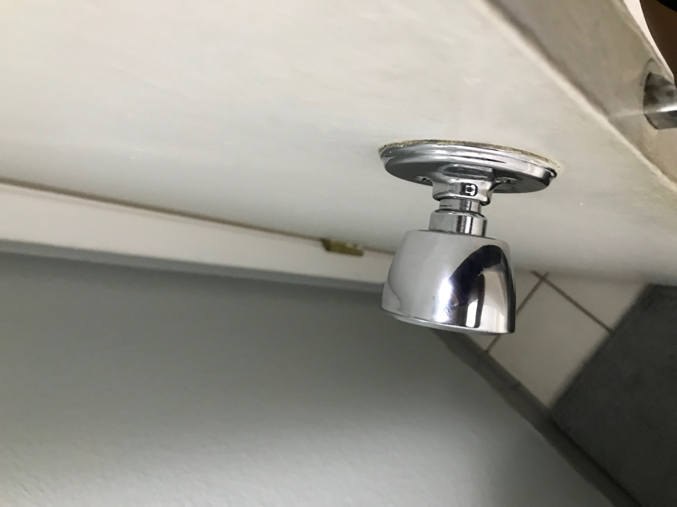

GOOD

This power bank is an example of good feedback because the light lets you know when the power is on and how much it has. So it lets you know that a phone has been plugged in and it is charging it.

